
Vulnerability Assessment & Penetration Testing (VAPT)
Identification of Security Vulnerabilities Using VAPT
Methodology

Environment Setup & Target Identification
Setup
Kali Linux attacker machine aur DVWA target machine ko Host-Only Network par configure kiya gaya taake isolated aur unauthorized testing environment banaya ja sake.
Kali is a attacker machine and dvwa is a target machine and both are set on the host only netwrok to configure isolated and unauthorized testing enviroment and ICMP confirm the connectivity.
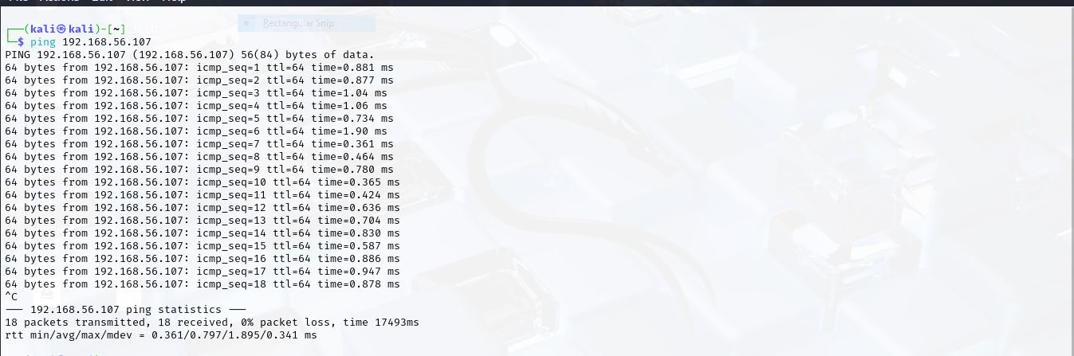
Kali is a attacker machine and dvwa is a target machine and both are set on the host only netwrok to configure isolated and unauthorized testing enviroment and ICMP confirm the connectivity.
Host discovery
ICMP Echo (Ping) Scan

Ping confirmed the the target machine is alive.
TCP ACK Ping
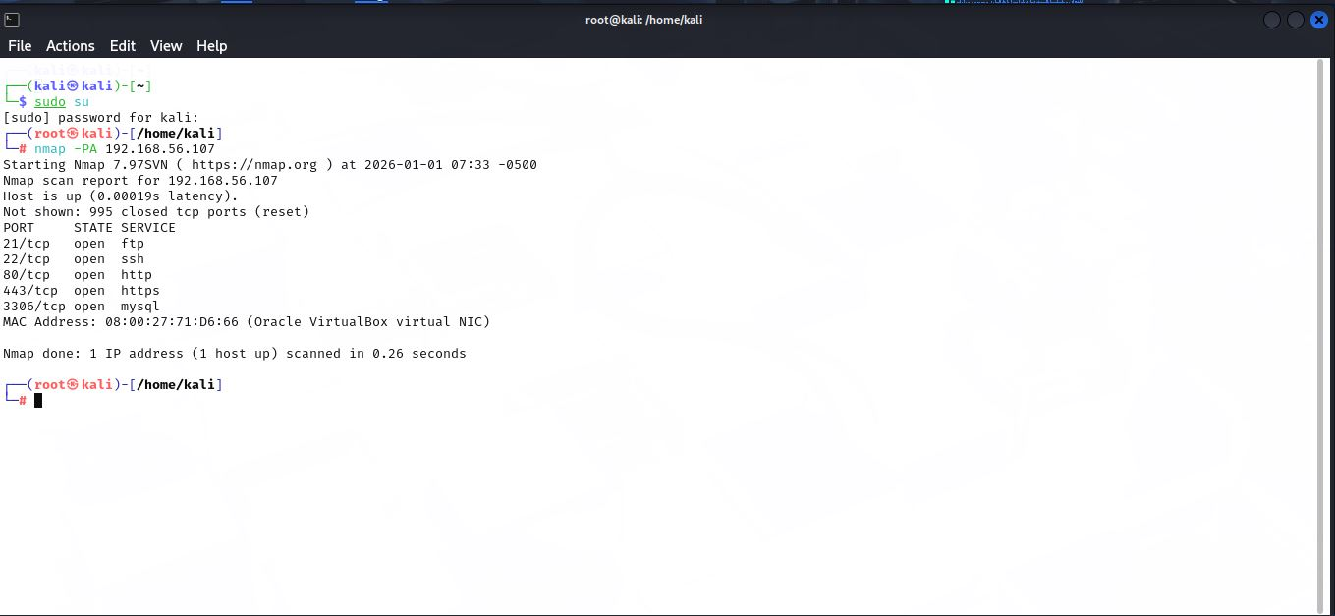
It send the tcp packet to to check the target machine is alive or not and the result of the scan show the multiple ports are open http 80 show thw DVWA web application is accessible and use for the vulnerability testing
SCTP INIT Ping
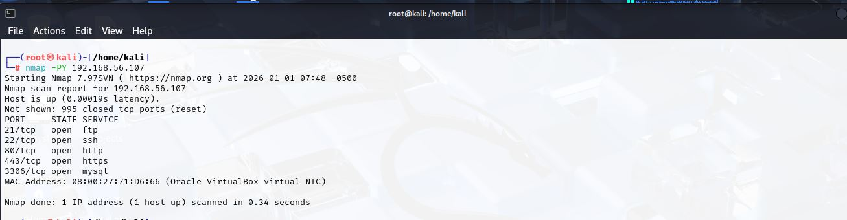
Stream control transmission protocol use tu check the system avaliablity.
ICMP Timestamp Ping Scan
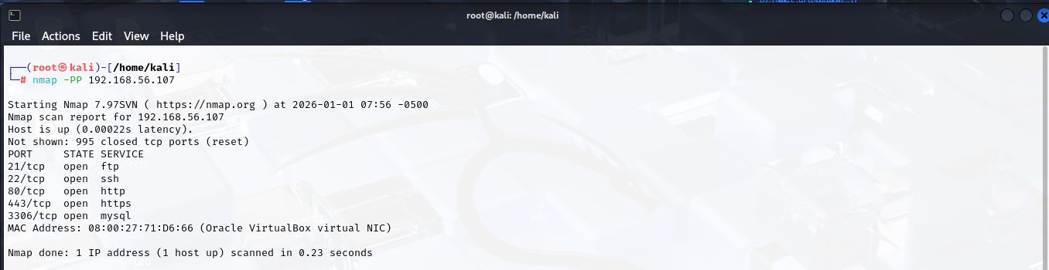
Icmp timestamp request packets send to the target ip in this request is not blocked and send the reply to nmap means the system is alive.
ICMP Address Mask Ping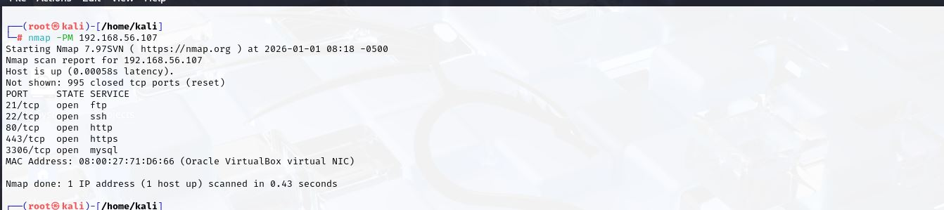
Icmp address mass ping scan use for the network configuration information.
ARP Ping (LAN only)
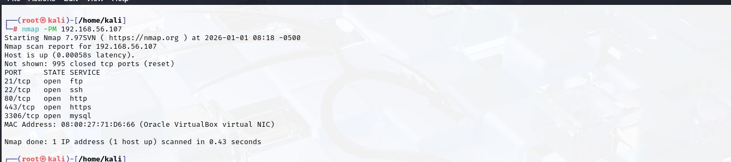
ARP is use to detect the host and mac address in the local enviroment.
MAC Address Identification
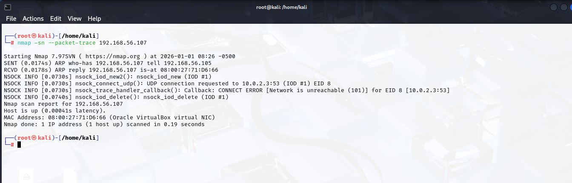
Nmap us the ARP based discovery and find the mac address of the target machine and it is match to the oracle virtual box which is indicate the target machine host in the local lab enviroment.
OPERATING SYSTEM DISCOVERY
OS Detection (TTL based)
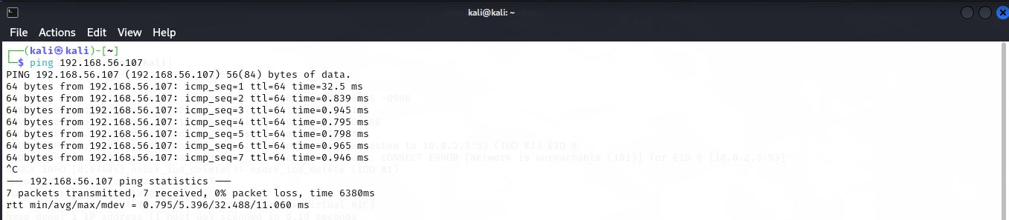
Ping command target machine receive the icmp echo command in the reposne shown the ttl(time to live) value is 64 this prove the target system linux based operating system use because the ttl 64 is bydefault for the linux system.
OS Fingerprinting (Unicornscan)
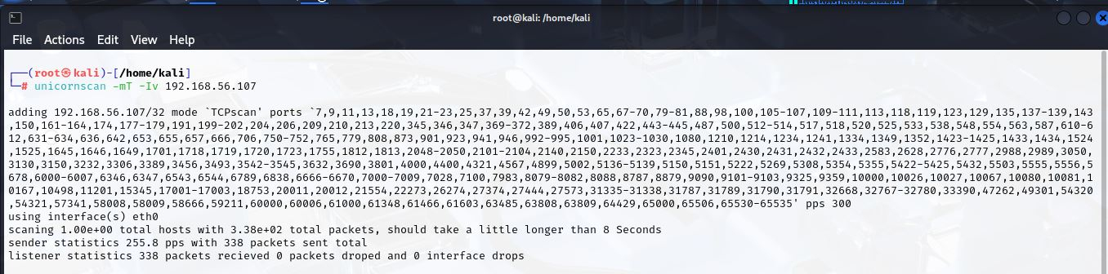
Unicorntool use and perform the fingerprinting on the traget machine dusrig the scan send packets on the multiple tcp ports and receive the sucessfully which is confirm the target reacheability.Packets behaviour and privious ttl based analysis confirm indicate the target machine is in the linux operating system.
OS Detection using NSE
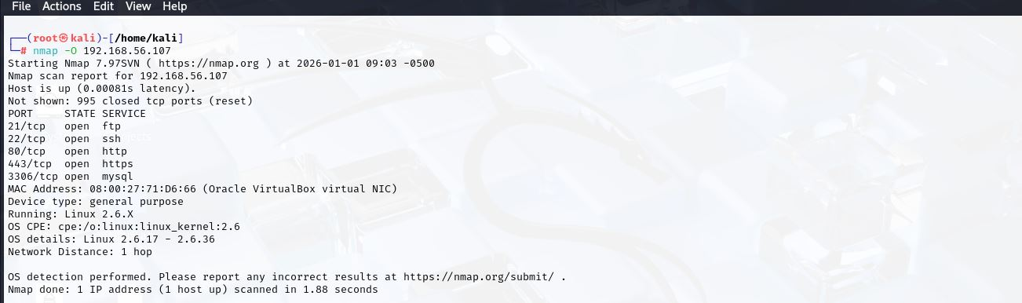
Nmap –O scan find the target machine use the linux based operating system.
PORT & SERVICE DISCOVERY
TCP Connect Scan
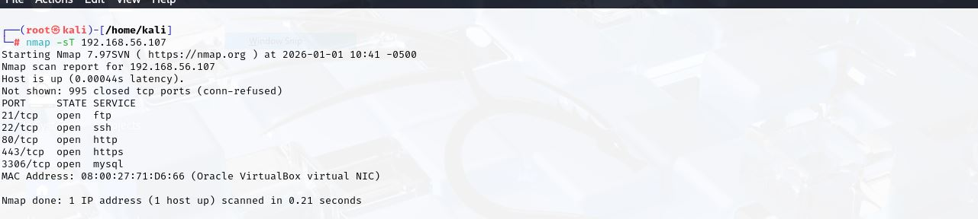
TCP scan perform from them establish the full tcp connection and identify the which ports is open so we analyze the mutliple ports are pen like ftp,http,ssh which proof the service actively run on the target system
UDP Scan
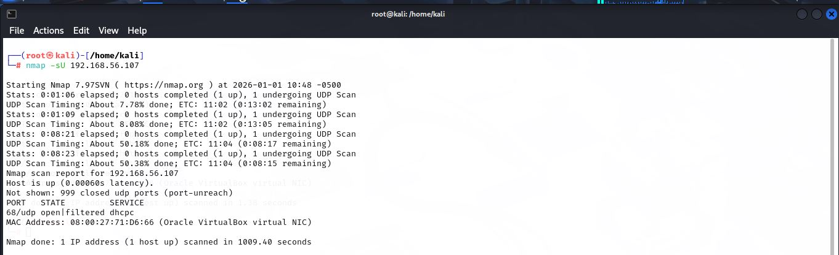
This scan analyze the udp based service which analyze the udp ports is in the open filtered indicate the service is active or filtered the udp firefall filtered. It is the time consuming because the udp protocol is connection less.
TCP NULL Scan
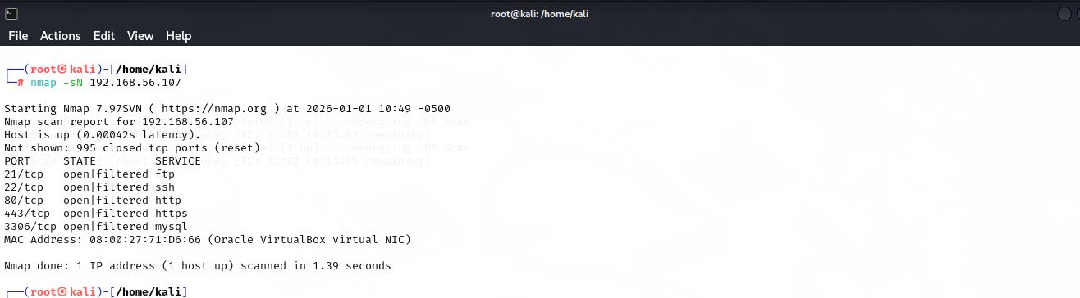
Tcp packets send without any flag to the target system and the result to find multiple ports open filtered which indicate the firewall and filtering mechanism restrict the resonse. This scan use to analyze the firewall behaviour.
TCP FIN Scan
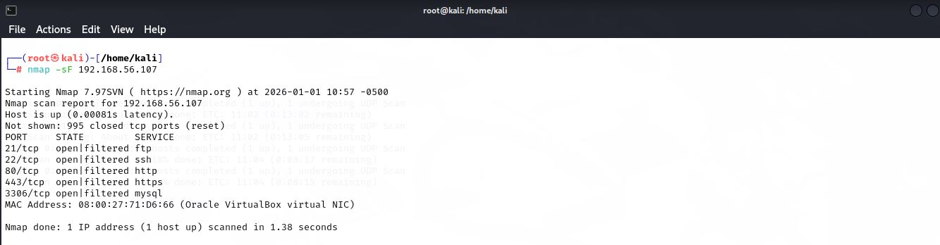
Tcp fin flag use to perofrm scan in the result mutilple ports open filtered observe which indicate the firwall filter pakcets. This stealth scan reconniscance open ports detetion.
Xmas Scan
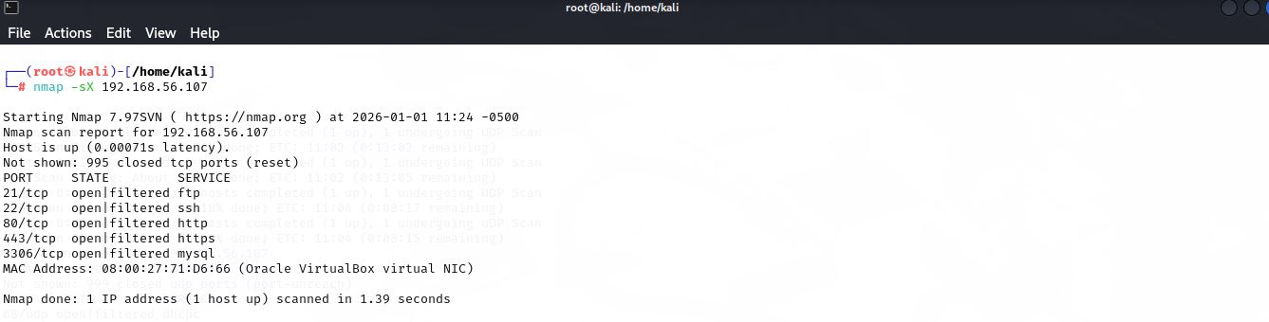
Xmas scan in which multiple flag combine FIN,PSH URG and analyze the target machine tcp ports in the result multiple tcp open filtered obeserve which indicate the firwall filter the tcp packets.
TCP ACK Scan
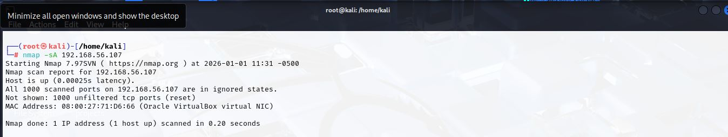
This tcp scan use to analyze the firewalls rules and also shown ip and mac address of the target system.
TCP Window Scan
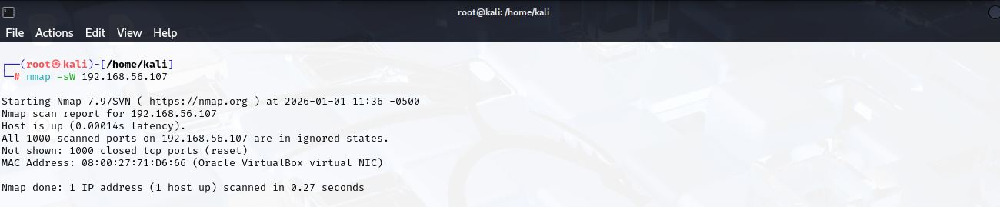
This scan give the ports state information.
TCP Maimon Scan
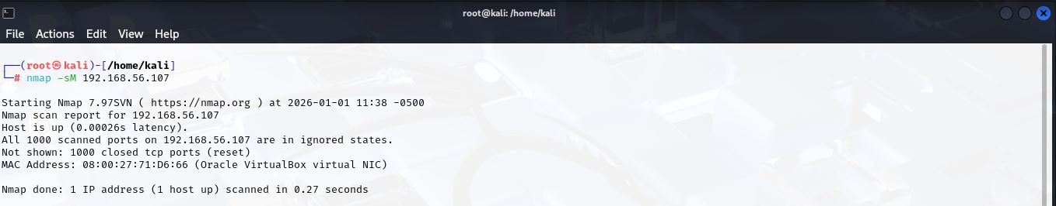
unusual TCP port response behavior ka analysis karna tha. Scan results me zyada tar ports open filtered state me nazar aaye, jo yeh indicate karta hai ke system ya firewall FIN+ACK packets par clear response nahi de raha.
IP Protocol Scan
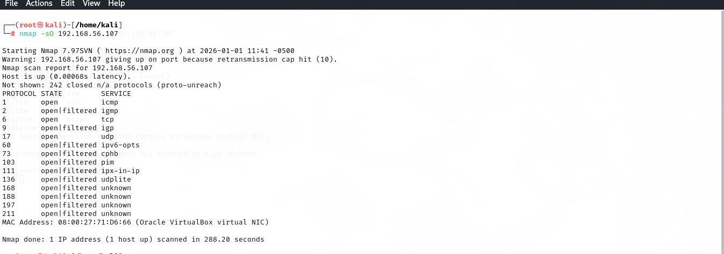
IP Protocol Scan tcp protocol and also identify the supporting network protocol.
SNMP Enumeration
SNMP Enumeration using Nmap
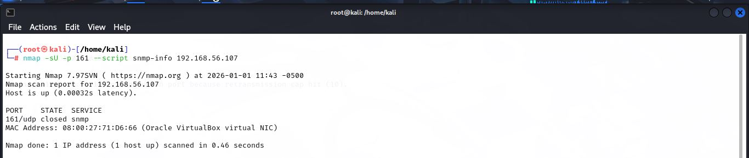
Snmap service on target is closed which ensurethe system safe from the based information discolosure.
Firewall / IDS Evasion Techniques
Fragmented Packet Scan
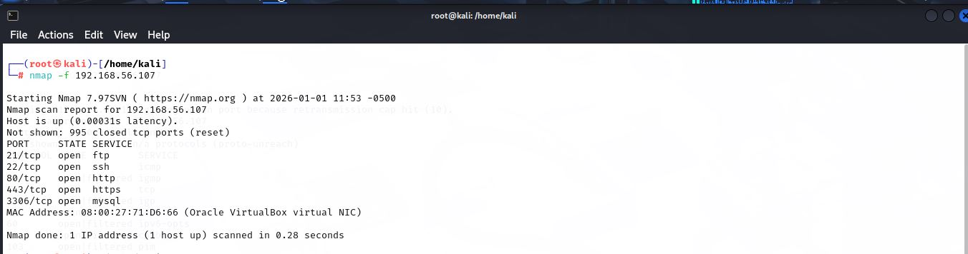
Fragmented packet scan firewall evasion techniques analyze karne ke liye use ki gayi. Is scan se yeh pata chalta hai ke target network fragmented packets ko detect aur block kar raha hai ya nahi.
Decoy Scan
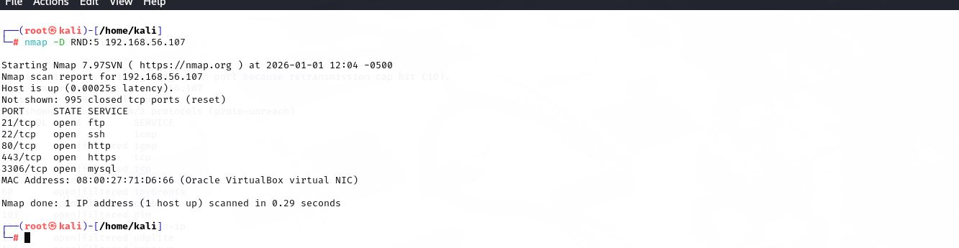
Decoy scanner is use to hide the attacker identity mechanism obeserve.
Source Port Spoofing
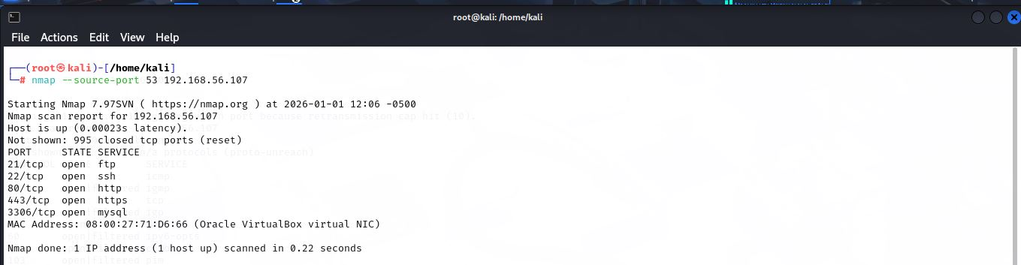
Trusted source ports use to bypass the firwalls rule.

Concise Summary of Findings
Active hosts
The DVWA target machine 192.168.56.107 is active and reachable. Multiple host discovery techniques were used during the assessment, including ICMP-based and TCP-based scans, which consistently confirmed that the target system was alive and responding to network requests. This confirmed that the target environment was properly configured and accessible for further vulnerability assessment and penetration testing activities.
Open ports and services
Multiple TCP ports detected including HTTP (80), FTP, and SSH, which indicates that several services are actively running on the target system. The availability of the HTTP service confirms that the DVWA web application is accessible and can be used for vulnerability testing. UDP ports were mostly observed in an open|filtered state, which suggests that UDP services may either be active or filtered by firewall rules due to the connectionless nature of the UDP protocol.
Detected operating systems
The target system was identified as a Linux based operating system using TTL analysis, OS fingerprinting, and NSE scans. The TTL value of 64 observed in ICMP responses aligns with the default TTL value used by Linux systems, and this finding was further validated through multiple OS detection techniques.
Any notable or unusual behavior
Firewall filtering observed in stealth scans such as NULL, FIN, Xmas, and Maimon scans, where multiple ports appeared in an open|filtered state, indicating active firewall or packet filtering mechanisms. Fragmented packets and trusted source port scans indicate firewall trust rules behavior, showing how the firewall handles fragmented traffic and traffic originating from trusted ports.

